Part Number: PTR13-35150
Kit Contents
Item # | Quantity Reqd. | Description
1 | 2 | Coil/ Shock Assy, Front
2 | 2 | Shock, Rear
3 | 1 | Hardware Bag
Hardware Bag Contents
Item # | Quantity Reqd. | Description
1 | 1 | Brake Line Spacer
2 | 1 | Brake Line clamp
3 | 2 | Cushion Retainer, Bottom
4 | 2 | Nut
5 | 2 | Nut
6 | 1 | Bolt
Additional Items Required For Installation
Item # | Quantity Reqd. | Description
1
2
3
Conflicts
Tacoma 4cyl and/or 4X2: TRN*, GRN225, GRN250, GRN265, GRN270
Recommended Tools
Personal & Vehicle Protection | Notes
Blanket | Placing engine under cover in bed of truck.
Special Tools | Notes
Alignment Equipment
Installation Tools | Notes
3/8” Drive Sockets | 12mm, 13mm, 14mm; 5mm Allen
1/2” Drive Sockets | 17mm, 19mm, 21mm
Ratchet | 3/8” & 1/2”
Crowfoot | 22mm
Wrench | 15mm, 19mm, 22mm & 26mm
Torque Wrench | 3/8” & 1/2"
Screw Driver | Phillips #2
Paint Marker
Special Chemicals | Notes
Medium Strength Thread Locker | Permatex® BLUE Gel
General Applicability
Tacoma V6 Pre-Runner & 4X4
Recommended Sequence of Application
Item # | Accessory
1 | TRD Suspension
2 | TRD Skid Plate
3
*Mandatory
Vehicle Service Parts (may be required for reassembly)
Item # | Quantity Reqd. | Description
1
2
3
Legend
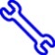
STOP: Damage to the vehicle may occur. Do not proceed until process has been complied with.
OPERATOR SAFETY: Use caution to avoid risk of injury.
CAUTION: A process that must be carefully observed in order to reduce the risk of damage to the accessory/vehicle and to ensure a quality installation.
TOOLS & EQUIPMENT: Used in Figures calls out the specific tools and equipment recommended for this process.
REVISION MARK: This mark highlights a change in installation with respect to previous issue.
SAFETY TORQUE: This mark indicates that torque is related to safety.

Care must be taken when installing this accessory to ensure damage does not occur to the vehicle. The installation of this accessory should follow approved guidelines to ensure a quality installation.

These guidelines can be found in the "Accessory Installation Practices" document.

This document covers such items as:-
- Vehicle Protection (use of covers and blankets, cleaning chemicals, etc.).
- Safety (eye protection, rechecking torque procedure, etc.).
- Vehicle Disassembly/Reassembly (panel removal, part storage, etc.).
- Electrical Component Disassembly/Reassembly (battery disconnection, connector removal, etc.).

Please see your Toyota dealer for a copy of this document.

Remove the Front OE Shock Assemblies.
  - Place the vehicle in Park (AT) or in gear (MT).
  - Put a brake hold tool in place (PPO).
  - Raise the vehicle to the highest lift position.
  - Remove the front wheels.
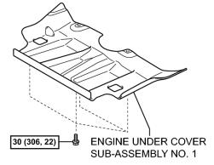
  - Use a 12mm socket to remove the four bolts from the engine under cover sub-assembly No. 1(Fig. 1-1) Remove the cover and retain it and the bolts for reinstallation.
Fig. 1-1
12mm socket and ratchet

  - Remove the front shock absorber with coil spring assembly.
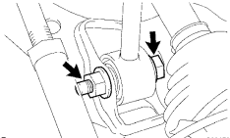
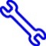
    - Use a 19mm wrench and 19mm socket to remove the lower bolt, nut and washer (Fig. 1-2). Retain them for reinstallation.
Fig. 1-2
19mm wrench, 19mm socket & ratchet
HINT: Move the brake caliper up and down slightly to allow the bolt to slide out.

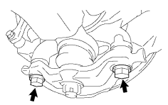
    - Use a 19mm socket to remove the two bolts from the lower ball joint assembly (Fig. 1-3). Retain them for reinstallation.
Fig. 1-3
19mm socket & ratchet

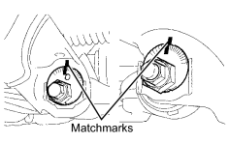
    - Place matchmarks at the top of the front and rear alignment cams to indicate the original position before loosening them (Fig. 1-4).
Fig. 1-4
Marker, 19mm socket & ratchet

    - Use a 19mm socket to loosen (do not remove) the lower control arm cam bolts & nuts to allow the lower control arm to swing down freely.
        - At the front of the arm, loosen the bolt head facing forward.
        - At the rear of the arm, loosen the nut facing rearward.
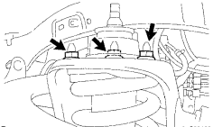
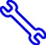
    - Use a 14mm socket to remove the three nuts on the upper side of the front shock absorber with coil spring assembly (Fig. 1-5). Remove the assembly from the vehicle.
Fig. 1-5
14mm socket and ratchet
HINT: Disassemble the other side before installing the new components.
CAUTION: Take care not to damage the axle CV boot or steering rack boot while lowering the assembly.

Install the TRD Shock Absorber Assembly.
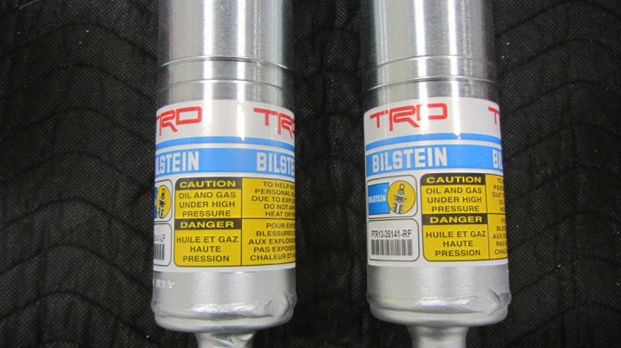
NOTE: The front shock absorber assemblies are marked left and right. Be sure to confirm the correct installation location based on the snap ring location (Fig. 2-5).
Fig. 2-1
Driver’s Side
Passenger’s Side

High position snap ring = Driver’s side
Low position snap ring = Passenger’s side

  - Use a 14mm socket to install the three nuts onto the upper side of the front shock absorber with coil spring assembly (Fig. 2-2).
Fig. 2-2
14mm socket & torque wrench

Torque: 47·lbf (64 N·m)
  - Raise the lower control arm and lower ball joint assembly so it contacts the steering knuckle.

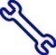
  - Use a 19mm socket to install and torque the front lower ball joint attachment with the two bolts (Fig. 2-3).
Fig. 2-3
19mm socket & torque wrench

WARNING: You MUST hand start these bolts before using an air tool.

Torque: 118ft·lbf (160 N·m)

  - Use a 19mm wrench and a 19mm socket to temporarily tighten the lower bolt, nut and washer as shown in Fig. 2-4.
Fig. 2-4
19mm wrench & socket
NOTE: Hand tighten for moving the vehicle to alignment.

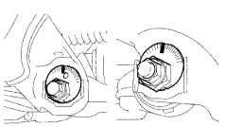
  - Align the adjustment cams to the marks made in Step 1(f)(3) (Fig. 2-5).
Fig. 2-5
19mm socket & ratchet
  - Use a 19mm socket to temporarily tighten the lower control arm bolts (Fig. 3-5). Snug with a ratchet is fine until alignment.

  - 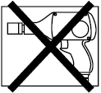Install the front wheel/tire assemblies onto the vehicle. Hand start the lug nuts during installation. Tighten the lug nuts in sequence 1 through 6 or equivalent star pattern (Fig. 2-6). Ensure that the socket does not scuff the wheels. Tighten to 83 ft-lbf (113 N-m) using a torque wrench.

Fig. 2-6
Torque 2 Cycles
(All Lugs/Locks)
2x

Torque: 83 ft-lbf (113 N-m)
  - Re-torque all lug nuts in the same 1-6 sequence (Fig. 2-6).

Torque: 83 ft-lbf (113 N-m)
CAUTION: DO NOT USE AN IMPACT WRENCH TO INSTALL OR REMOVE WHEEL LOCKS.

  - 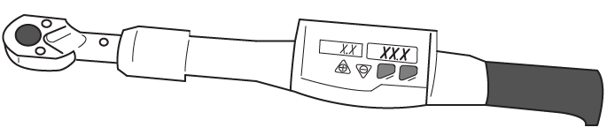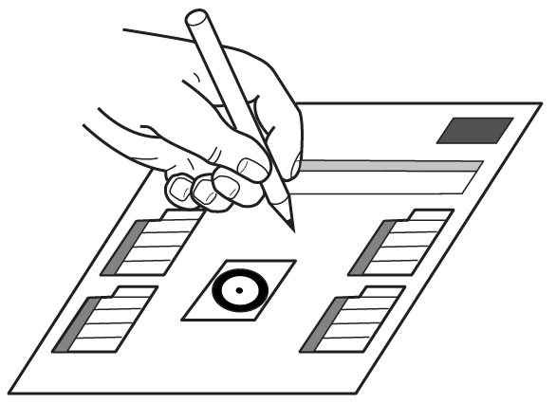With the vehicle still on the lift, use a digital torque wrench to measure the torque of each lug nut/lock and record it on the Torque Audit Sheet (Fig. 2-7) (PPO installation only, does not apply to DIO installation).

Fig. 2-7
Measure Torque and Document
(All Lugs/Locks)

Remove the Rear OE shocks.
  - Remove the rear wheels.
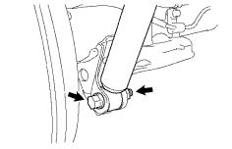
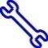
  - Separate the shock absorber from the rear axle housing (Fig. 3-1). Keep all hardware
Fig. 3-1
17mm socket & ratchet
HINT: Move the brake drum up and down to assist in removal of the bolt.

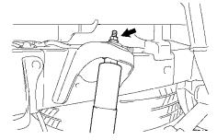
  - Remove the nut, three cushion retainers, cushion No. 1, cushion No. 3 and shock absorber (Fig. 3-2). Discard the bottom retainer and nut (Refer to Fig. 5-1).
Fig. 3-2
14mm socket & ratchet

Install the Rear Brake Line Spacer.
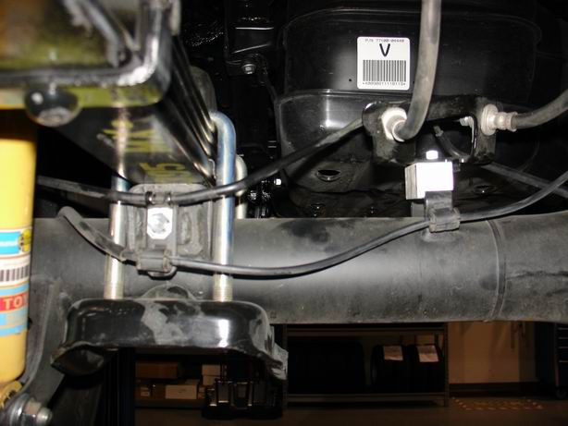
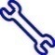
  - Remove brake tube clamp at the far left side of the axle housing and discard it (Fig. 5-1, Left).
Fig. 5-1
12mm, 13mm socket & ratchet
  - Remove the bolt holding the flexible hose bracket found on top of the axle housing (Fig. 5-1, Right).
  - Place the brake line spacer between the bracket and axle housing (Fig. 5-1, Right). Install the supplied bolt.
Torque: 15 ft•lbf (20 N•m)
  - Install the supplied brake tube clamp and tighten the bolt on the axle housing (Fig. 5-1, Left).
Torque: 108 in•lbf (12 N•m)

Install the TRD Rear Shock Absorbers.
  - Temporarily install the shock absorber lower mount with the bolt, nut and washer removed in Step 3(b).
NOTE: Hand tighten for moving the vehicle to alignment.

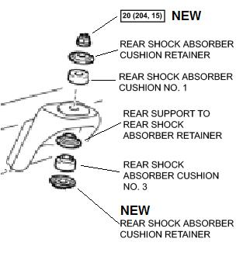
  - Install the new supplied lower cushion retainer onto the shock stud (Fig. 5-1).
Fig. 5-1
14mm socket & ratchet
  - Reinstall the cushion No. 3 and the original support retainer (Fig. 5-1).
  - Pull down on the shock body and insert the stud into the shock mount.
HINT: Rotate the body to loosen any sticking friction of the assembly.
  - Reinstall the cushion No. 1 top retainer and a new supplied nut (Fig. 5-1).

Torque: 15 ft•lbf (20 N•m)
  - Install the reservoir brackets onto the reservoirs.
    - Place one drop of Permatex® BLUE Gel into the threaded hole.
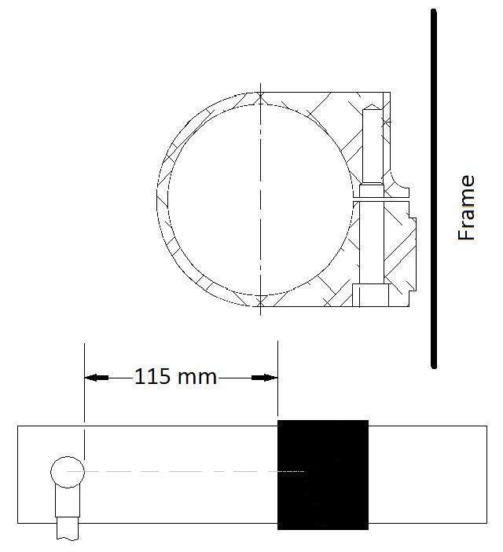
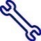
    - Slide the reservoir bracket onto the reservoir (Fig. 5-2).
Fig. 5-2
5mm Allen socket & ratchet
Bracket
Hose bung
    - Space the hose bung 115mm from the bracket (Fig. 5-2).
  - Rotate the reservoir body so that the hose bung is indexed perpendicular to the vehicle frame (Fig. 5-2).
  - Tighten the bolt to 69in•lbf (8 N•m).

Torque: 69in•lbf (8 N•m)

  - Mount the reservoirs to the frame.
    - Lower the spare tire 15 inches for better access to the fasteners on the driver’s side.
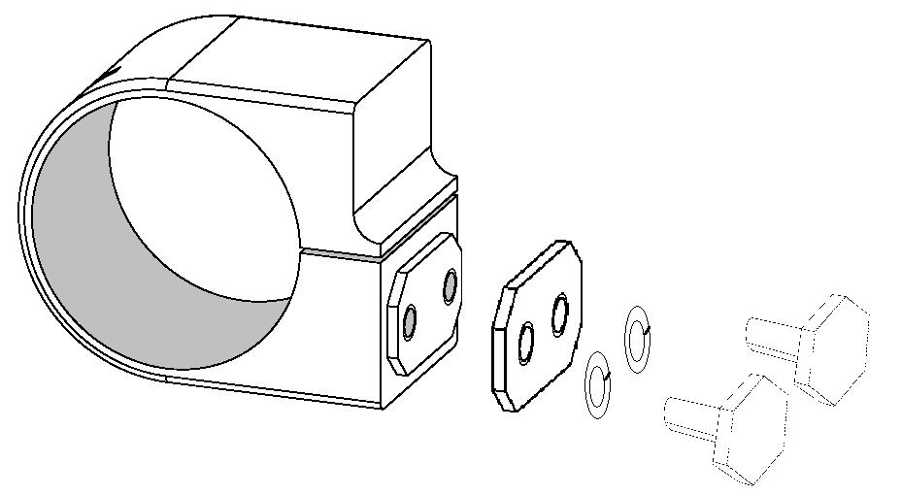
    - Place one drop of Permatex® BLUE Gel into threaded holes (Fig. 5-3).
Fig. 5-3
Thread locker
13mm socket & ratchet

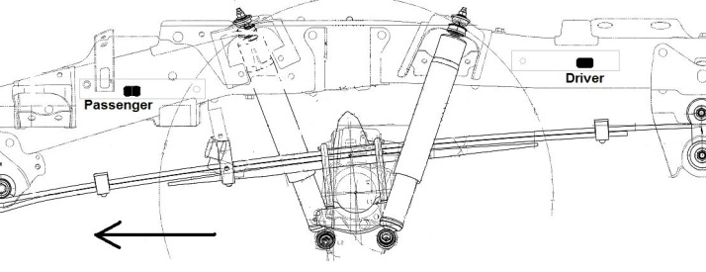
    - Locate the boss of the reservoir bracket into the datum hole to the right of the shock absorber (Fig. 5-4).
Fig. 5-4
Front

NOTE: The view in Fig. 5-4 is from the driver’s side.
    - Start both bolts by hand to hold the reservoir bracket, backing plate and lock washers in place.
    - Tighten both bolts.
Torque: 18 ft·lbf (25 N·m)
  - Install the rear wheel/tire assemblies onto the vehicle. Hand start the lug nuts during installation. Tighten the lug nuts in sequence 1 through 6 or equivalent star pattern (Fig. 5-5). Ensure that the socket does not scuff the wheels. Tighten to 83 ft-lbf (113 N-m) using a torque wrench.

Fig. 5-5
Torque 2 Cycles
(All Lugs/Locks)
2x

Torque: 83 ft-lbf (113 N-m)

  - Re-torque all lug nuts in the same 1-6 sequence (Fig. 5-5).

Torque: 83 ft-lbf (113 N-m)
CAUTION: DO NOT USE AN IMPACT WRENCH TO INSTALL OR REMOVE WHEEL LOCKS.
  - With the vehicle still on the lift, use a digital torque wrench to measure the torque of each lug nut/lock and record it on the Torque Audit Sheet (Fig. 5-6) (PPO installation only, does not apply to DIO installation).

Fig. 5-6
Measure Torque and Document
(All Lugs/Locks)

Adjust the Vertical Headlamp Aim.
  - Lower the vehicle onto the floor and remove the brake hold tool.
  - Back the vehicle up 2 to 4 feet and return to the original position.
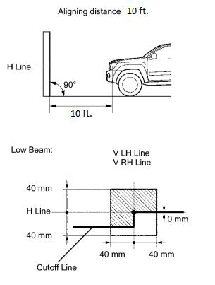
  - Place a white board 10feet in front of the vehicle (or use a flat wall). Low light conditions can help (Fig. 6-1):
Fig. 6-1
    - Use a location that is dark enough to clearly observe the cutoff line. The cutoff line is a distinct line, below which light from the headlights can be observed and above which it cannot.
    - Place the board at a 90° angle to the vehicle.
    - Keep a 10 ft distance between the center of the headlight bulb and the wall.
    - Ensure the vehicle is on a level surface.
    - Measure the height to the center mark on the headlight lens. This is your H Line height.

    - Mark this height on the wall in front of the vehicle (ex: use masking tape).
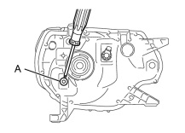
  - Adjust the vertical aim of the lamps (Fig. 6-2).
Fig. 6-2
#2 Phillips screwdriver
    - Cover the headlight on the opposite side to prevent light from the headlight not being adjusted from affecting the headlight aiming process.
NOTE: Do not keep the headlamp covered for more than 3 minutes. The headlamp can be damaged due to high heat.
    - Turn on the headlamps.
    - Adjust the headlight aim to within the specified range by turning aiming screw “A” with a screwdriver (Fig 6-2).
NOTE: The final turn with the screwdriver should be in the clockwise direction. If you pass the correct adjustment point, loosen the screw and then retighten it, so that the final turn of the screw is in the clockwise direction.
NOTE: Do not alter the horizontal adjustment.
NOTE: Since the low-beam light and the high-beam light are a unit, if the aim on one is correct, the other should be correct. The high-beam should only need verification and no adjustment, but check and adjust if necessary.

Adjust the Wheel Alignment.
  - Park the vehicle on the alignment rack at the designated location leaving the shift lever in “neutral” and the steering wheel pointed straight ahead.

  - Initialize the alignment system and measure the caster.
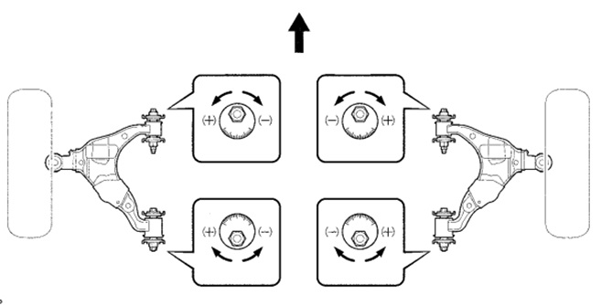
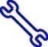
  - Loosen the adjustment nuts and bolts (Fig. 7-1).
Fig. 7-1
19mm & 26mm wrench
  - Turn the front adjustment cam and the rear adjustment cams as necessary. Adjust the camber and caster as close to the spec value as possible.
HINT: Start with the adjustment cams at the centered position.
    - The caster nominal reading is +2.00° (+2°00’). The range can be from +1.50° (+1°30’) to +2.75° (+2°45’).
    - The camber nominal reading is +0.59° (+0°35’). The range can be from -0.16° (-0°10’) to +1.34° (+1°20’).
  - Repeat Steps (c) and (d) for the other side.
  - The difference left to right must be 0.50˚ (0˚30’) or less for both caster and camber.
  - Make adjustments with the front cams as necessary.
  - Tighten the bolts to prevent movement.
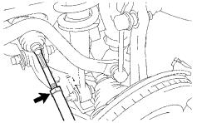
  - Loosen tie rod end lock nuts (Fig. 7-2).
Fig. 7-2
22mm wrench
  - Roughly adjust the toe settings so that the toe indicator arrow is in the green range.

  - Install a steering wheel holding tool. Insure that the steering wheel is completely straight.
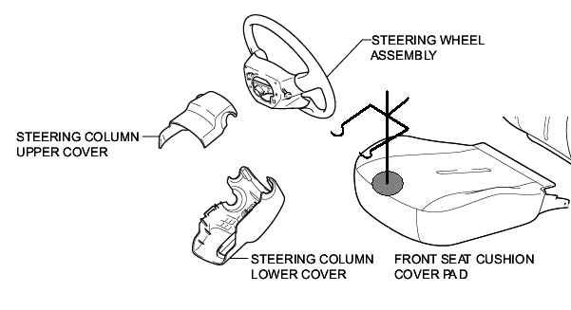
HINT: Line up the horn pad with the plastic garnish covering the steering column (Fig. 7-3).
Fig. 7-3
  - Make any final caster and/or camber adjustments.

  - Use a 19mm socket to torque the front and rear lower control arm bolts (Fig. 7-4).
Fig. 7-4
19mm socket & torque wrench

Torque: 100 lb·lbf (135 N·m)

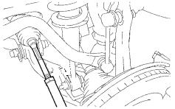
  - Adjust the toe (Fig. 7-5).
Fig. 7-5
15mm wrench
    - The nominal reading is +0.121° +/- 0.108° (0°07’+/- 0°06’) or 0.065 +/- 0.08 in. (1.64 +/- 2mm).

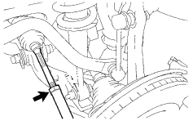
  - Use a 22mm crowfoot to torque the locking nut and be sure not to upset the final readings (Fig. 7-6).
Fig. 7-6
22mm crowfoot & torque wrench

Torque: 41 lb·lbf (56 N·m)
HINT: Turn the tie rod ends clockwise until they stop. Adjust the toe with additional “toe in” so that tension on the lock nut moves the wheel into specification.
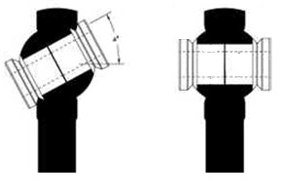
NOTE: After the lock nut is torqued, return the tie rod end to its neutral position on the ball joint (Fig. 7-7).
Fig. 7-7
  - Remove the alignment heads and return them to their storage location.

Complete the Assembly.
  - Use a 19mm wrench and 19mm socket to torque the front lower shock bolts (Fig. 8-1).
Fig. 8-1
19mm socket, 19mm wrench & torque wrench

Torque: 61 lb·lbf (83 N·m)

  - Use a 12mm socket to install the engine under cover and torque the bolts (Fig. 8-2).
Fig. 8-2
12mm socket and torque wrench

Torque: 22 lb·lbf (30 N·m)

  - Use a 17mm socket to torque the rear lower shock bolts (Fig. 8-3).
Fig. 8-3
17mm socket & torque wrench

Torque: 43 lb·lbf (58 N·m)
  - Confirm the steering wheel is straight while returning the vehicle to the main shop for additional assembly.

Accessory Function Checks
Verify the rear shock hoses are facing away from the frame at a right angle.
Confirm the rear shock reservoirs are not contacting the bed mounts.

Vehicle Function Checks
Check the steering wheel.
Verify the headlight aim.

5mm (0.2”) minimum

The steering wheel should be straight.
The headlight aim should be in spec.

Vehicle Appearance Check
After accessory installation and removal of protective cover(s), perform a visual inspection.

Ensure no damage (including scuffs and scratches) was caused during the installation process.
(For PPO installations, refer to TMS Accessory Quality Shipping Standard.)

